BasenjimomsKitchen.com is a website dedicated to all things kitchen.

By reading my latest recipes, cooking tools and gadgets reviews and food tips, you will be able to…
- Improve your and your family’s health and well-being with healthy food options and fresh ingredients
- Select and monitor ingredients you put and add to the dishes you cook for yourself and your loved ones
- Learn about a couple of kitchen appliances, tools and gadgets that will help you speed up the process of cooking, preserve ingredients and experience convenience, especially if you don’t have much time to cook but still want to get the most out of food and select only the best products out there for your kitchen
- Stay updated on the latest cooking tips that you can make use of in improving not only the taste of food but also your well-being
- And so much more

Just like you, I do not settle for unhealthy food choices, as I am so much concerned about how the food we eat affects our overall health condition. In this case, I also research and look for alternatives to cooking healthy in less time, and those things we learn, I share on my blog.

Cookware Sets
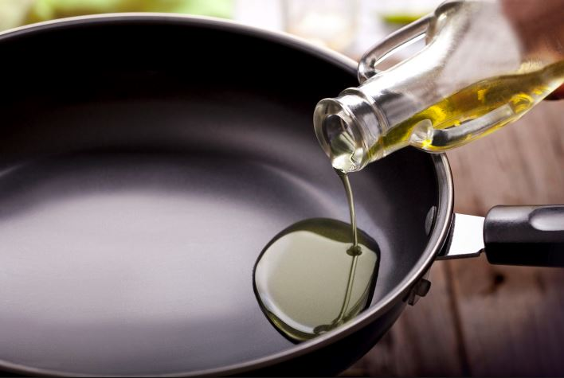
No matter whether it is your cookware set or whether the old pots are simply obsolete. The purchase of a new set of pots and pans needs to be carefully considered, because the new pots and pans should accompany you as long as possible.

We have therefore compared several types of cookware in different price ranges for you. So you can find the right pot set that meets your requirements.

The cookware set is an essential part of a perfect household equipment. Such a set is not only suitable for initial equipment, but also if you want to treat your kitchen to a fresh cell cure, it will be good for you. Not only do the pots have a homogeneous appearance, but you also get all the important variants at one go. Whether pressure cooker, frying pan, roaster or just a normal cooking pot - depending on the package, the composition varies slightly.

Our large pot set comparison shows you which sets are really recommendable and where the price-performance ratio and quality are right. When comparing, you should also make sure that each pot in the pot set is dishwasher safe and ovenproof. Our detailed guide also deals with the different materials and gives you valuable tips on all aspects of the pot set. Frequently asked questions are also answered in detail.

Food Processors
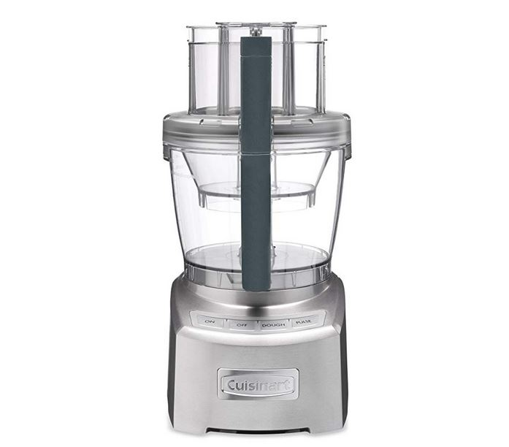
Kneading, grating, stirring, grating, baking, pressing, pureeing, cutting - a multitude of very different work steps are required in the kitchen. Granted: most of them can be done by hand. But it's easier with a little electric helper that takes the effort off your shoulders. This is best done with a universal food processor.

But before you rush off and eagerly reach for the next best appliance that falls into your hands, you should think about it a little. Because even if they combine many functions, food processors are large appliances and take up a correspondingly large amount of space in the kitchen. So when you buy one, it should be really versatile so that it doesn't just gather dust most of the year.

Food processors make time-consuming work during cooking and baking much easier, clearing the way for relaxed preparation of food, cakes, pasta and bread. In the following we will introduce you to the main components of most kitchen machines and explain why appliances with integrated cooking function are not always the best choice.

Blenders
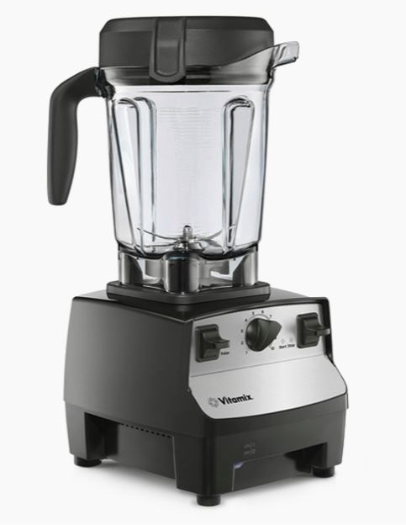
In the long run, anyone who wants to eat fresh and nutritious food will not be able to avoid preparing it themselves. But there are many small and large helpers in the kitchen to make the work easier and faster. One of these devices, which is finding its way into more and more American kitchens, is the blender.

This is a food processor with which you can mix the currently popular smoothies, among other things. Such a blender, unlike a hand blender, has the rotating blades integrated directly into the container. All you have to do is press a button and the kitchen blender does its job virtually by itself.

How well it does this depends on various criteria that we have included in our blender comparison 2020. We have summarised the most important points for this in this purchasing advice.

Stand mixers are primarily used for the production of smoothies. In their mixing jug they usually hold much larger quantities of food than the plastic mixing cup of a hand blender. If you also want to chop fibrous, stubborn kale for green smoothies, you need at least 1,000 watts of power and 25,000 revolutions per minute. So-called high-performance mixers meet these criteria. Note: Highly motorised blender stands reach enormous heights in terms of noise levels - but fortunately only for a short time. If you have sensitive ears, you should therefore be careful to choose a device that has a sound power level of "only" around 80 db(A).

Juicers
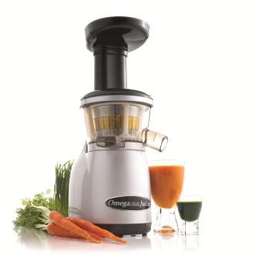
When looking for a juicer, you will always come across the terms slow juicer, centrifugal juicer or juicer. The differences lie in the technology and the suitability of the devices for certain types of fruit and vegetables.

Centrifugal juicers are considered high-speed juicers because of this somewhat rough treatment. And this is their biggest advantage. With a powerful machine you can produce really litres of juice in the respective operating time. I will say more about operating times, the resulting litre specifications and other requirements later. But this speed also has a disadvantage:

With fixed juicing, first of all frictional heat and kinetic energy are generated, secondly a lot of oxygen comes into play. Heat and air are two things that vitamins and minerals can't stand. I already gave a detailed talk on this in the blender test. This does not mean that the juice from the centrifugal juicer is a worthless broth of fructose and flavours. But the nutrient and mineral content is still reduced.

With these aspects in mind, I leave it open whether Slow Juicer is really the better alternative to centrifugal juicers.Here, the liquid is not beaten out by means of rubbing and centrifugal force, but practically massaged out by a roller screw. That's why you often find the synonym juice squeezer, although I would rather use this term for the citrus classic.

Toaster Ovens
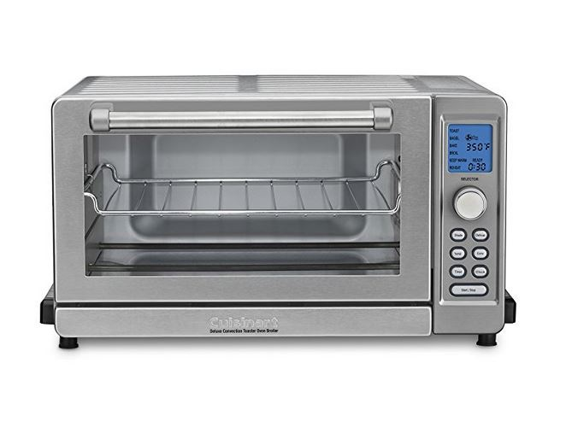
Mini ovens, sometimes also known as toaster ovens, were long considered a niche product for clever energy savers. Their field of application was clearly defined. Crisping up rolls for breakfast, baking a small snack for in-between or preparing a portion of frozen food - the mini ovens were ideal for such tasks. They reached temperature faster than a large oven, and a cooking chamber with a smaller volume also had to be heated.

But the compact ovens - even in terms of their dimensions - have recently become much more compact, which means they are technically upgraded and offer much more than the term mini oven would suggest.

Coffee Makers
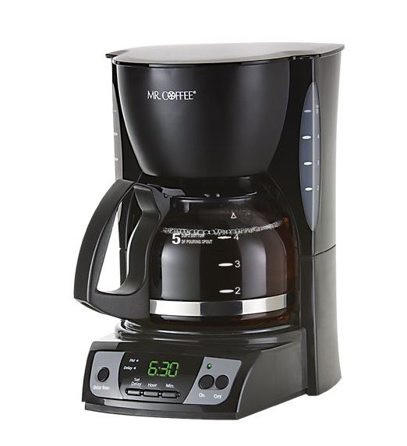
There are people for whom a good new day begins with an invigorating cup of coffee. As the day progresses, there are more opportunities for a cup of the aromatic hot drink. Coffee can be found in numerous variations around the globe. There are also numerous ways to prepare a coffee drink. One of them is brewing in a coffee filter machine.

Coffee is not only a luxury food, but has long been part of the staple diet for many people: the black potion made from the exotic roasted bean transforms tired marmots into everyday heroes every morning - whether behind the wheel of a truck or in an office chair. In the afternoon, the hot drink of tropical origin is also on the programme and is served with cakes and sweet snacks from the pastry shop.

We have compared several coffee machine types. We will go into the equipment, functions and other facts. In our guide, you will learn everything you need to know about filter machines and their handling. Last but not least, we look at the coffee machine tests by Stiftung Warentest and Öko Test.

***

Contact us now:
Basenjimomskitchen.com
Website: https://basenjimomskitchen.com/
Twitter: https://twitter.com/basenjimomcom
Facebook: https://www.facebook.com/BasenjiMomCom/
Mastodon: https://mastodon.social/@basenjimom
Gettr: https://gettr.com/user/basenjimomskitchen
Spoutible: https://spoutible.com/basenjimomskitchen
Post.news: https://post.news/@/basenjimomcom
Gab: https://gab.com/basenjimomskitchen
Classic Google Site: https://sites.google.com/site/basenjimoms/
New Google Site: https://sites.google.com/view/basenjimom/
Phone #: 312-909-7691
Address: 1730 18th St #195, Bakersfield, CA 93301

