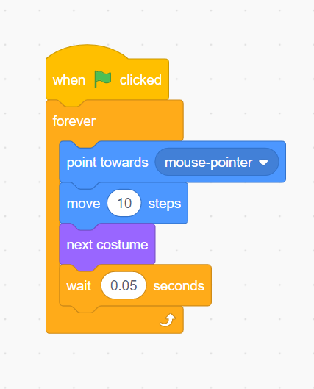
LEVEL 1 - SHARK SCRIPTS

LEVEL 2 - FISH SCRIPTS

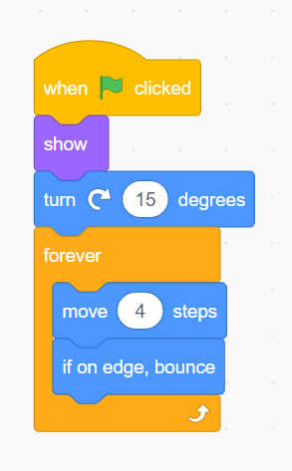

LEVEL 3/4 - MAKING THE FISH DISAPEAR & ADD A SCORE
ADD THIS TO THE FISH

