The Importance of Levels

Introduction: What are levels / zones & why are they important in day trading
- Key levels are a major part of technical analysis. They are identified as support and resistance. As a trader you should be familiar with the basics of support and resistance and how to identify them on a chart.
- Support: An area when a stock is trending down where there is demand / buying interest at a certain price point or “zone” (demand zone).
- Resistance: An area when a stock is trending up where there is selling interest at a certain price point (supply zone).
As a day trader you need to eliminate a biased take on whatever stock you are trading. You can have an idea of where a stock is going to move, but you realistically have no idea. You want to be reactive in the market. If I am not buying commons or starting a swing position in either direction, why would I care / try to predict what is going to happen? All I need is to be able to identify key levels that are respected to use them to my advantage.
Example : $NIO

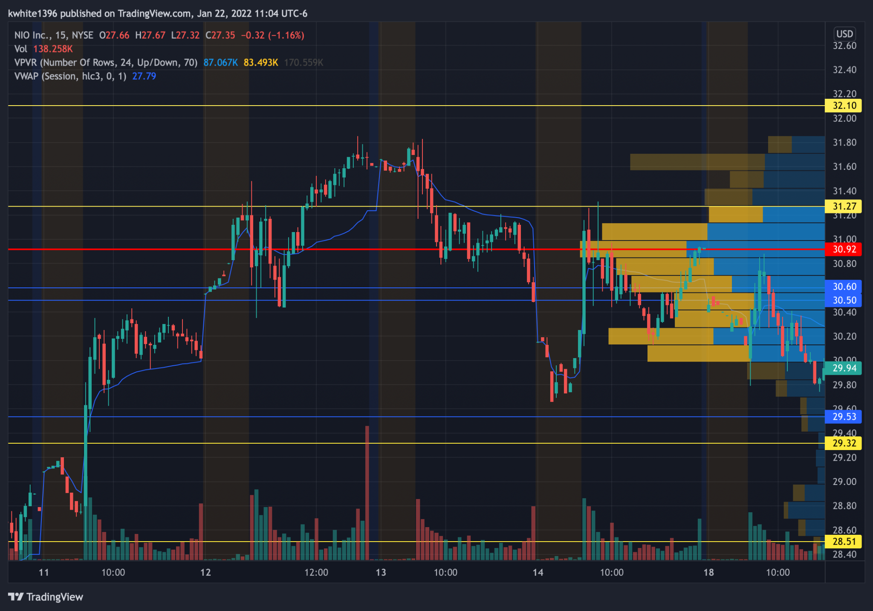
This is $NIO on the 15 minute chart.
- 31.30 is a respected level for NIO
- Looking left you can see NIO making its way up towards 31.30 & rejection / a pause at the level multiple times acting as resistance.
- You also see the level at 30.50 act as support here. Price continues to move up and now we see the break of 31.30 & a retest of the level which now acts as support.

Now NIO is making its way down
- As NIO approaches 31.30 what do we see? Bounces off the level now acting as support. It first was resistance & now acting as support.
- We see NIO break 31.30 and after the candle closes it tests the level again before making its way down. (Break & retest)
- You could have used 31.30 for calls or puts. On the bounce when acting as support for an intraday scalp for calls, or for puts on the break of the level to the downside.

Let's look at $SPY from a watchlist I made this week
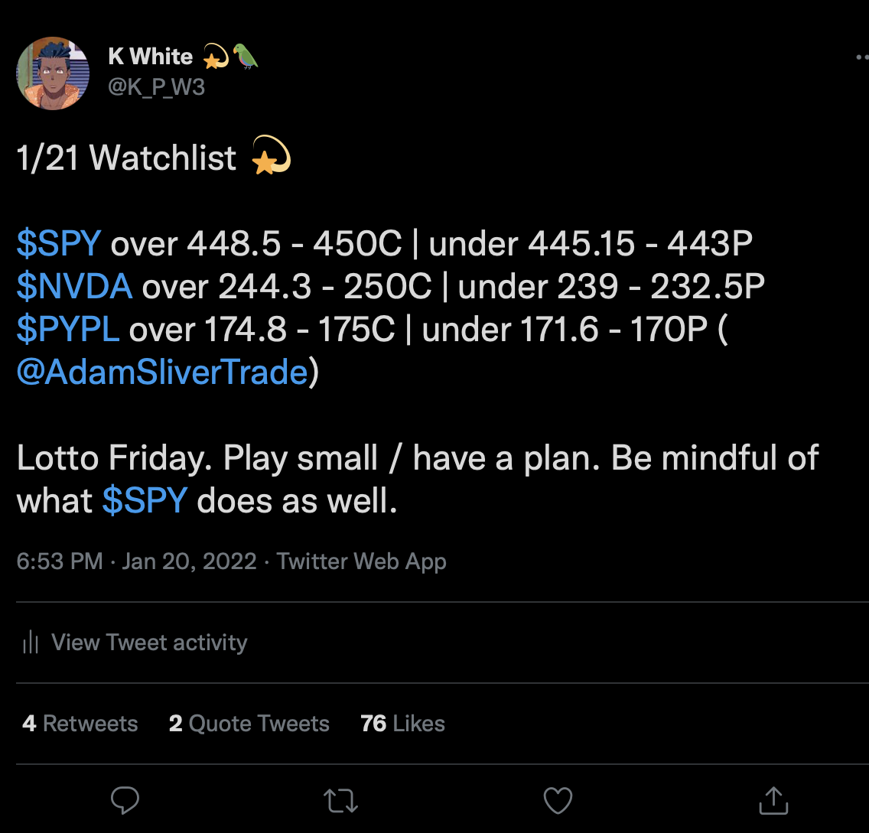

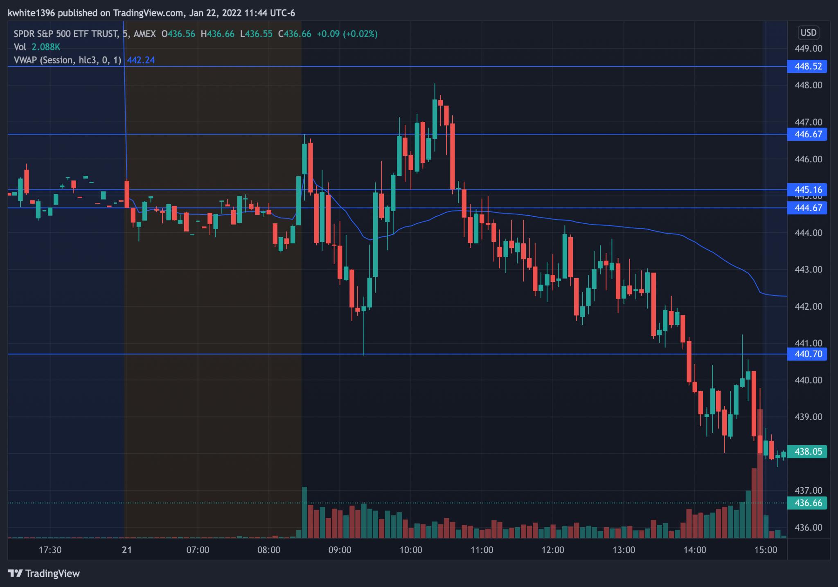

$SPY on the 5 minute chart
- Let's look at the intraday level of 445.15 that I identified.
- Under 445.15 I said puts.
- At the open this level was tested twice and rejected to the downside all the way to 440.70
- As price makes its way back to 445.15 what do you see? Rejection. It is acting as resistance. Once it breaks through it comes back down and tests the level and is now acting as support. Price bounced off 445.15 and climbed to 448.05.
- As price starts moving down, what do you see? Pauses at the level before continuing its downtrend.

You could have played puts off this level multiple times intraday and also calls as well. When identifying key levels intraday all you are looking for is the level to act as support & resistance in the past and reacting to how price moves when its around that level.

A watchlist build with “trigger” levels is telling you to be reactive to levels because like I said they have acted as support AND resistance. All I am doing intraday for day trades is buying calls or puts based on how price moves off these levels that I identified.

