Power BI December 2021 Feature Summary

Welcome to the December 2021 update. We are happy to release Sparkline preview feature for tables and matrixes, more updates for the new Format Pane, several connector updates and public preview of Hybrid Tables support for Power BI Premium. There is more to explore, please continue to read on.

Reporting
Sparklines (Preview)
New Format Pane in Preview updates:
Data connectivity and preparation
Azure Data Explorer (Connector Update)
FHIR (Connector Update)
Dremio Software (Connector Update)
BQE Core (Connector Update)
What's new in BQE CORE Connector 2.0?
TIBCO Data Virtualization [GENERALLY AVAILABLE]
Exasol (Connector Update)
Starburst Enterprise (Connector Update)
Service
Admin & governance
Email subscriptions access via Admin API
Allow sharing links to include your changes to the report
Announcing Public Preview of Hybrid Tables in Power BI Premium
Mobile
New report default view
Recommended Content supports hints (Android and iOS)
Mobile support for Goals - latest updates
Embedded Analytics
Support Power BI dataset as a data source for embedding paginated reports
Client API updates - Themes
Azure Power BI Embedded A7 and A8 capacity nodes self-service
Power BI Developer in a Day online course is updated
Developers
Improve your matrix performance with the new 4.1 API
Visualizations
New visuals in AppSource
Shielded HTML Viewer by Nova Silva
graphomate charts 2021.4
Zebra BI Cards by ZADNJA VERZIJA
Try to use process mining through Business Intelligence by PmBI
Drill Down Combo Bar PRO by ZoomCharts
Other
Visualize your data quickly from Power Apps and Dynamics 365 apps (preview)

Reporting

Sparklines (Preview)
We’re very excited to preview sparklines, a popular feature request, as part of this month’s update. Sparklines are tiny charts shown within cells of a table or matrix that make it easy to compare a large number of trends quickly. You may want to use sparklines to show trends in a series of values, such as seasonal increases or decreases, economic cycles, or to highlight max and min values.
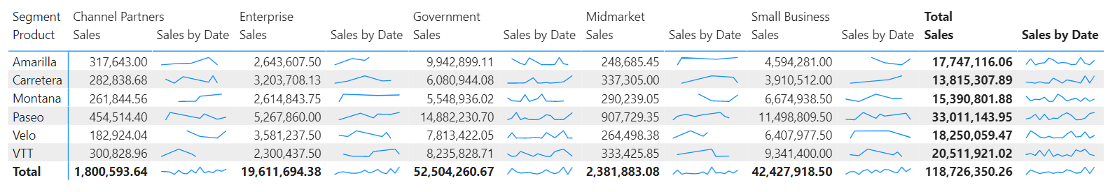

When the preview feature is enabled, you’ll be able to add sparklines to both your table and matrix visual through the field well. Just open up the context menu for one of your numeric fields and select Add a sparkline.
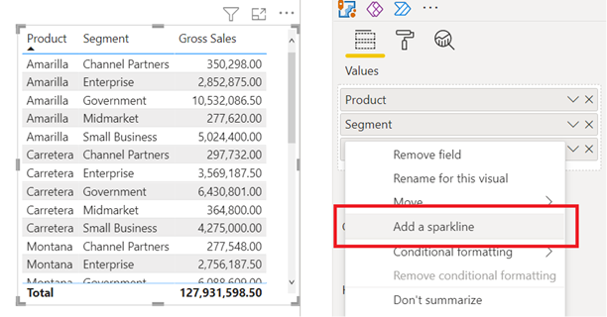
A dialog will appear to let you configure the details of your sparkline. The numeric field you started with will be prepopulated for the y-axis, but you are able to change both the field and summarization type if needed. You’ll also need to select a field, such as a date column, to use as the x-axis of the sparkline.
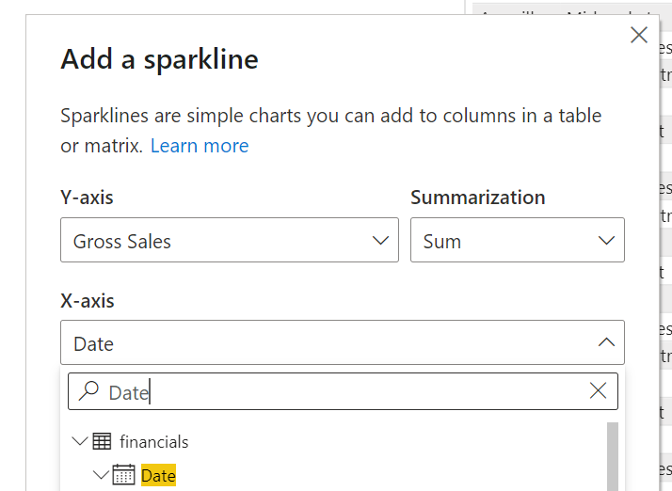
Once you click Create, your sparkline will be automatically added to your table or matrix as a new column.
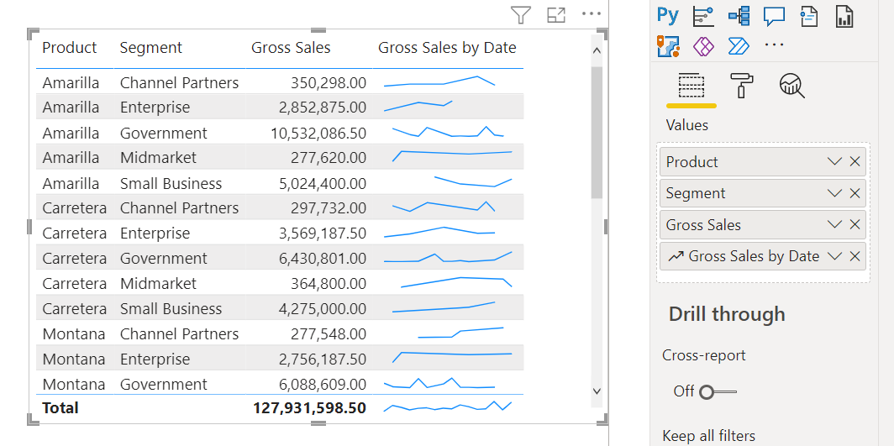
You can always edit the sparkline’s properties through the Edit sparkline option in the value’s context menu.
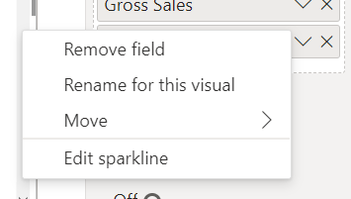
You can use the Sparklines card in the formatting pane to modify the sparkline’s line and marker formatting. You’re able to change the line color and width, add markers for different value types (highest, first, last, etc.), and change the marker size, color, and shape.
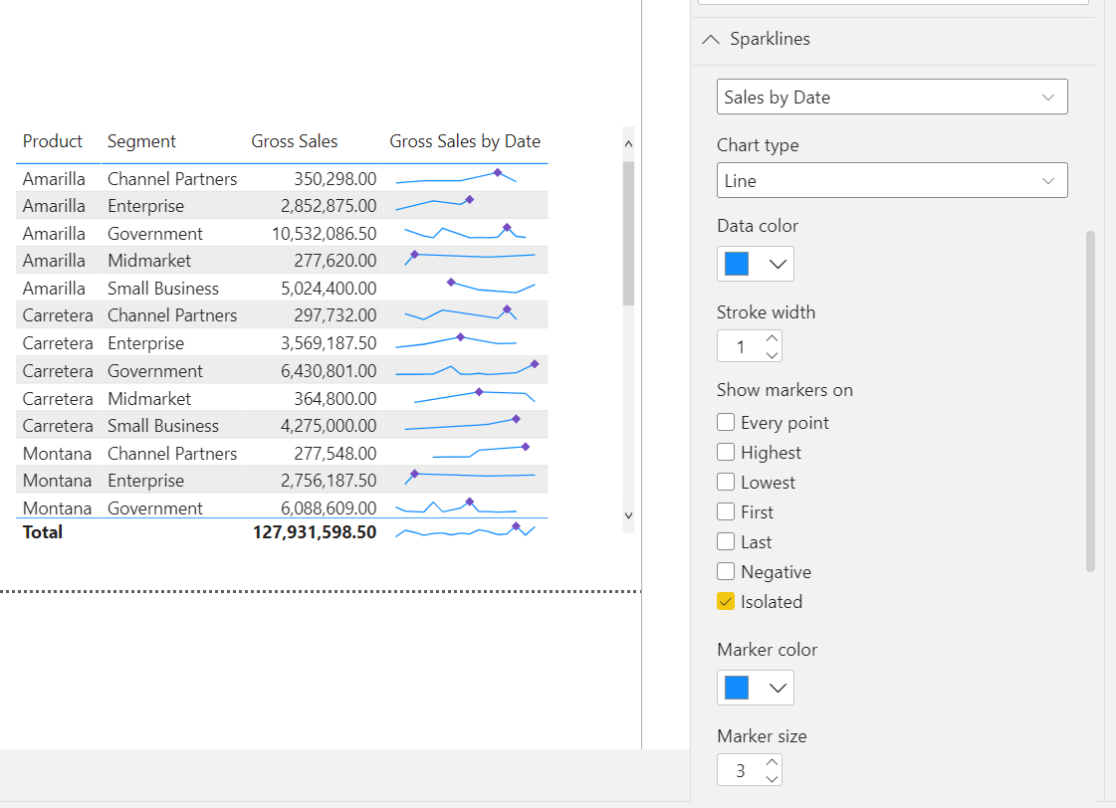
This is also where you can change the chart type from a line to a column chart.
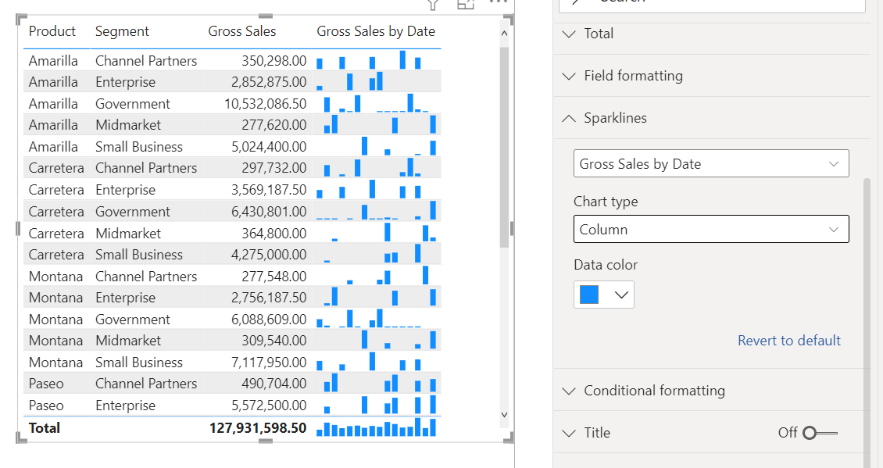
Give the feature a try and let us know what else you’d like to see added in the future!

New Format Pane in Preview updates:
- To address concerns we’ve heard around the extra clicks needed to find settings, the context menu “expand all categories” now expands all cards and sub-categories to meet user expectations.
- The following missing settings have now been re-added:
- Action card for buttons, shapes, and images.
- Responsive toggle and data limit settings for General > properties.
- Global text size for table/matrix.
- Background for Scatter chart > category labels.
- Analytics > Ratio line for scatter charts.
- Numeric input truncation and incorrect red borders bugs have both been fixed.

Data connectivity and preparation

Azure Data Explorer (Connector Update)
The Azure Data Explorer connector has been updated with the following changes:
- Fixed support for authentication against Log Analytics/Application Insights/Azure Monitoring resources
- Support folding of Bitwise Shift Left/Right operations
- Fixes to Text.PositionOf folding
- Accepting batch requests (only last result set will be used)

FHIR (Connector Update)
The FHIR connector has been updated with a fix for an issue where data was not filtered when additional query parameters were appended.

Dremio Software (Connector Update)
The Dremio Software connector has added the ability to authenticate using Azure Active Directory (AAD) in addition to the existing username and password, or username and personal access token methods.

BQE Core (Connector Update)
The BQE Core connector has been updated. Please see update notes from the BQE Core team.

What's new in BQE CORE Connector 2.0?
More data access via the BQE CORE connector, including:
- Contacts
- CORE CRM
- Fund Transfers
BQE CORE is proud to offer its Power BI connector directly through the Microsoft Power BI app. This connector gives users the ability to seamlessly import their raw CORE data into the Power BI application, as well as transform it into meaningful, centralized, visual and interactive insights for their business. While the connector was previously offered as a manual integration through our training department, this streamlined installation from the Power BI app will help CORE customers create custom dashboards and reports, and ultimately make more informed business decisions.

Visit the Power BI Forum to learn just how powerful this connector really is – and why you can’t afford to be without it! Also, be sure to explore our full list of public CORE APIs here

TIBCO Data Virtualization [GENERALLY AVAILABLE]
This connector is now generally available.

Exasol (Connector Update)
This update enables the “View Native Query” option.

Starburst Enterprise (Connector Update)
The Starburst Enterprise connector has been updated. Please see update notes from the Starburst team
(Version 3.0.0 # November 2021).
- Support for version 2.0.0+ of the Starburst ODBC driver.
- Breaking changes: Remove support for the Presto ODBC driver (prior to ODBC version 2.0.0).

Service

Admin & governance

Email subscriptions access via Admin API
Email subscription to reports and dashboards is a popular feature that makes it easy for you to stay up to date about the data that matter the most. To make this feature more useful, customers have been asking for the ability to give admin visibility into these subscriptions so that they can be on top of governance and control. It was nearly impossible to support scenarios like PII data breach/leak magnitude assessment through subscriptions, particular in the Healthcare sector. It required going through the UI, but it was cumbersome and inefficient. You could gain insight into subscriptions by analyzing the audit logs, but that can only go back 90 days at most. Today we are releasing to Public Review a set of Admin APIs to return a list of email subscriptions that have been created in the entire tenant. Check them out here and let us know of any feedback!
Admin - Dashboards GetDashboardSubscriptionsAsAdmin - REST API (Power BI Power BI REST APIs) | Microsoft Docs
Admin - Reports GetReportSubscriptionsAsAdmin - REST API (Power BI Power BI REST APIs) | Microsoft Docs
Admin - Users GetUserSubscriptionsAsAdmin - REST API (Power BI Power BI REST APIs) | Microsoft Docs

Allow sharing links to include your changes to the report
We’re excited to announce that the new link sharing experience now supports the option to share your explored version of the report through Include my changes:
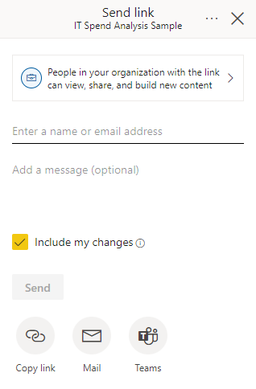
You can use this setting to create a shared view of the report that includes any of the filters or changes you’ve made to the report within read mode.
The Include my changes setting includes any changes to the following:
- Filters (filter pane or URL filters)
- Slicers
- Personalize visuals
- Cross-filtering or cross-highlighting
- Drill down or drill up
- Applied bookmark
- Spotlight
To learn more about the feature, checkout our documentation.

Announcing Public Preview of Hybrid Tables in Power BI Premium
We are excited to announce support of Hybrid Tables in Power BI Premium, which enables us in turn to announce an equally exciting and groundbreaking enhancement to incremental refresh – incremental refresh augmented with real-time data!!! Now you can have blazing fast performance in import mode and the latest data changes in the data warehouse reflected in user reports without having to perform a dataset refresh. For technical details concerning incremental refresh, see the article Incremental refresh for datasets in Power BI in the product documentation.
Up until now, dataset creators sometimes had to make hard tradeoffs between query performance and data freshness. Import mode delivers best performance, yet data freshness poses challenges if new data arrives at a very high cadence. It is both resource intensive and inefficient to import data into a dataset in very short intervals. DirectQuery mode, on the other hand, delivers data freshness, yet at the expense of report performance. Because Power BI doesn’t import the data but translates the report queries into data source queries, the latest data changes are quicky picked up, but the query/response roundtrips between Power BI and the data source take time and slow down the reports.
As the following diagram illustrates, a hybrid table can help to strike the right balance between query performance and data freshness. A hybrid table is essentially a (large) table that has one or multiple import-mode partitions as well as another partition in DirectQuery mode. If the DirectQuery partition is sufficiently small in comparison to the import-mode partitions, the query/response roundtrips between Power BI and the data source should still be reasonably fast while access to the bulk of the data is already super-fast in import mode. Import and DirectQuery data is presented to users as a single table with business definitions and calculations.

Mobile

New report default view
Most of us hold our phones in portrait orientation when we look at them, but for the most part, Power BI reports are designed for viewing in landscape orientation on computer screens. As a result, when you look at a report on your phone, the mobile app often requires you to tilt your phone on its side in order to see the report (unless the report has a mobile-optimized layout). This can be very annoying, especially when some of the report's pages are optimized for viewing on mobile devices and others are not.
In this Power BI Mobile update, we've removed that constraint. Now you can choose to view any report page (mobile-optimized or not) in the orientation you want. If the report page you’re looking at does not have a mobile-optimized layout but you want to hold your phone in portrait orientation, you’ll just get a smaller landscape view of the report.

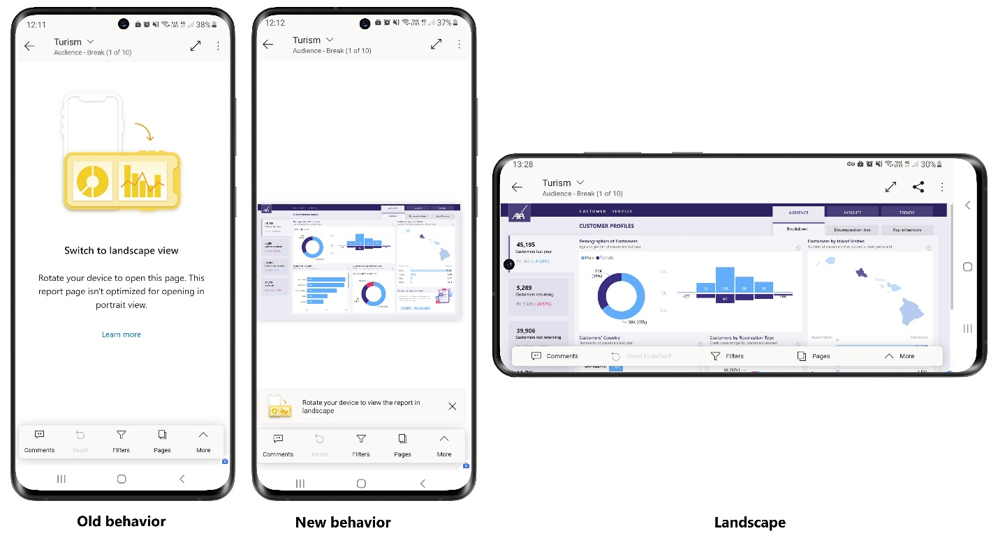

You can always tilt your phone to landscape orientation for a closer look at your data, but if all you need is a quick look at the numbers, you can quite easily stay in portrait orientation and just use pinch and zoom.
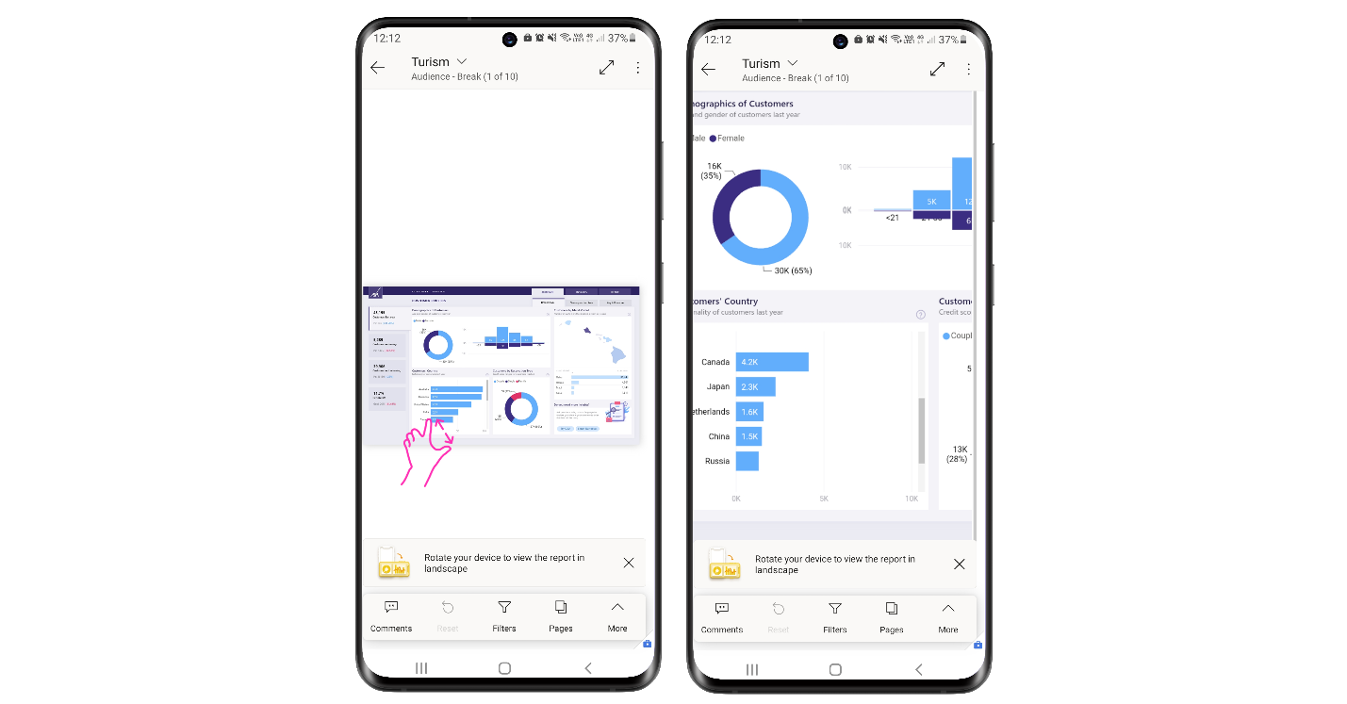

Recommended Content supports hints (Android and iOS)
We’ve added hints to the items recommended for you by Power BI to help you understand why the items were picked for you as recommended content. Being able to see who opened, certified, or published an item can help you decide whether the item might be relevant for your work.
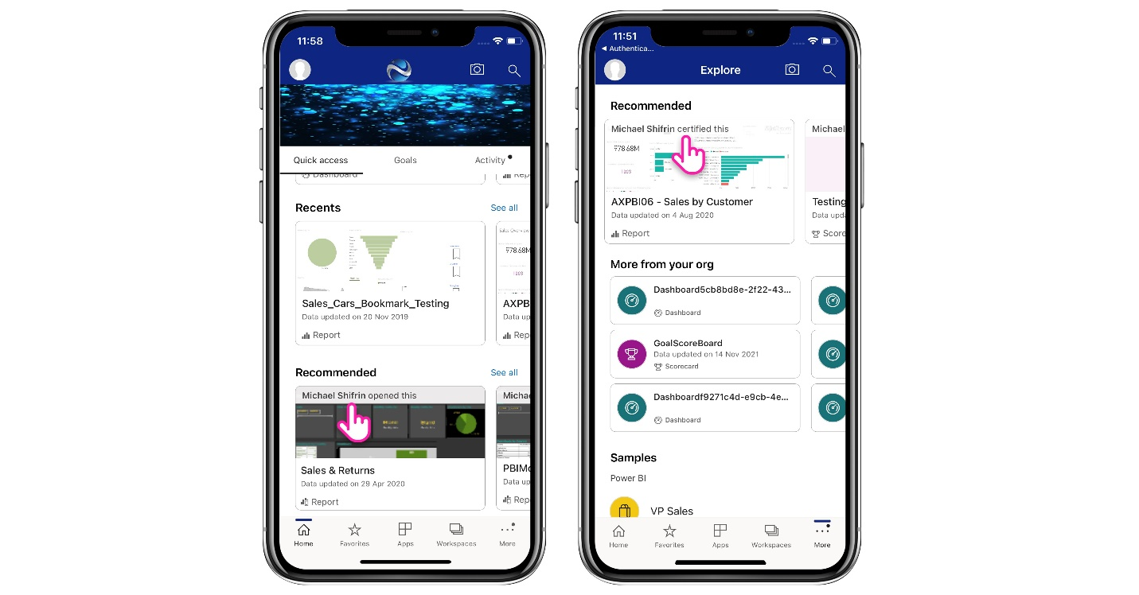

Mobile support for Goals - latest updates
The mobile apps for iOS and Android now support Goal-level permissions and scorecard column customizations that have been set up by the scorecard author.

Goal-level permissions in Power BI enable scorecard authors to grant different levels of access to different users for specific goals. For instance, some users may be permitted to add notes to a goal and/or to update the goal's status and current value, while other users may only be allowed to view specific goals within a scorecard. The mobile apps now support Power BI's goal-level permissions model.

Scorecard creators can also determine which columns consumers can see, ensuring that each scorecard shows only those columns that are appropriate to their scenario. The Power BI mobile apps support such customizations, and will adjust the fields shown, and the check-in data that is required, accordingly.

Embedded Analytics

Support Power BI dataset as a data source for embedding paginated reports
With Power BI embedded analytics, ISVs and customers can create Power BI content that displays paginated reports in a fully integrated and interactive application. They can embed paginated reports using the solution that works best for you, embed for your customers, or embed for your organization.
Until now, Power BI dataset was not supported as a datasource for those scenarios, and now we’re enabling it.
When embedding a paginated report with a Power BI dataset as a datasource for the embed for your customers scenario, you need a service principal and a multi-resource embed token, that contains a new parameter called “XMLA permissions”. When the value of this parameter is “Read Only”, ISVs and customers can control the access to XMLA endpoints.
Power BI datasets with datasources that require single sign-on (SSO) are not supported yet, but that’s coming soon.

Client API updates - Themes
Power BI report themes allow to apply design changes to an entire report. For example, customers can include their corporate colors, and change their icon sets. Developers using Power BI embedded analytics also can embed a report with a custom theme applied instead of the default theme for the report. Applying a theme this way loads the same report with different themes to different users according to their settings. In addition to the applyTheme API, we’re adding now the getTheme to allow ISVs obtain the embedded Power BI Report theme and potentially apply it to their own web app.
In addition, 2 properties were added to the Page class:
- Background - The background color of the page and its transparency.
- Wall paper - The wallpaper color of the page and its transparency
Both can be returned from the methods report.getActivePage() or report.getPages().

Azure Power BI Embedded A7 and A8 capacity nodes self-service
A7 is like P4 capacity node, carrying 64 v-cores and 200GB RAM. A8 is like P5 capacity node, carrying 128 v-cores and 400GB RAM. Both capacity nodes could be purchased by special request only, and now we’ve enabled their purchase in self-service, either through the Azure Portal or using an ARM API

Power BI Developer in a Day online course is updated
The Power BI Developer in a Day online course empowers app developers with the technical knowledge required to embed Power BI content. They are now updated with all the new features, and we highly recommend our developer customers to watch those videos and in the recorded sequence, starting with video 1 and ending with video 21.

Developers

Improve your matrix performance with the new 4.1 API
With the new 4.1 API you can fetch the custom matrix data on expand/collapse in a similar way to native matrix. Data will be fetched on demand and therefore optimize the performance of your custom matrix.
How to enable this feature?
The expand/collapse API requires the selectionId of the selected node.
It will be triggered by the selectionManager.toggelExpandCollapse () method. For more details see this document.

Visualizations

New visuals in AppSource
The following are new visuals this update:
- Data map by dTyp
- ProcessChampion by Argent Logic
- Ultimate UpSet Plot by Samuel Gratzl
- LeapLytics - Traffic Light by LeapLytics GmbH
- Deneb: Declarative Visualization in Power BI by Daniel Marsh-Patrick
- Inforiver Standard Matrix / Table by Lumel
- Icon Pack by TME AG
- HTML & CSS Viewer by K Team Solutions GmbH

Shielded HTML Viewer by Nova Silva
All HTML rendered through the Shielded HTML Viewer is sanitized to keep your data safe. But sometimes our sanitation process is too strict. Based on valuable feedback from our users we concluded the use of images became a victim of this strict sanitation process. So, we added support for images to the Shielded HTML Viewer! But without the need for risky external links.

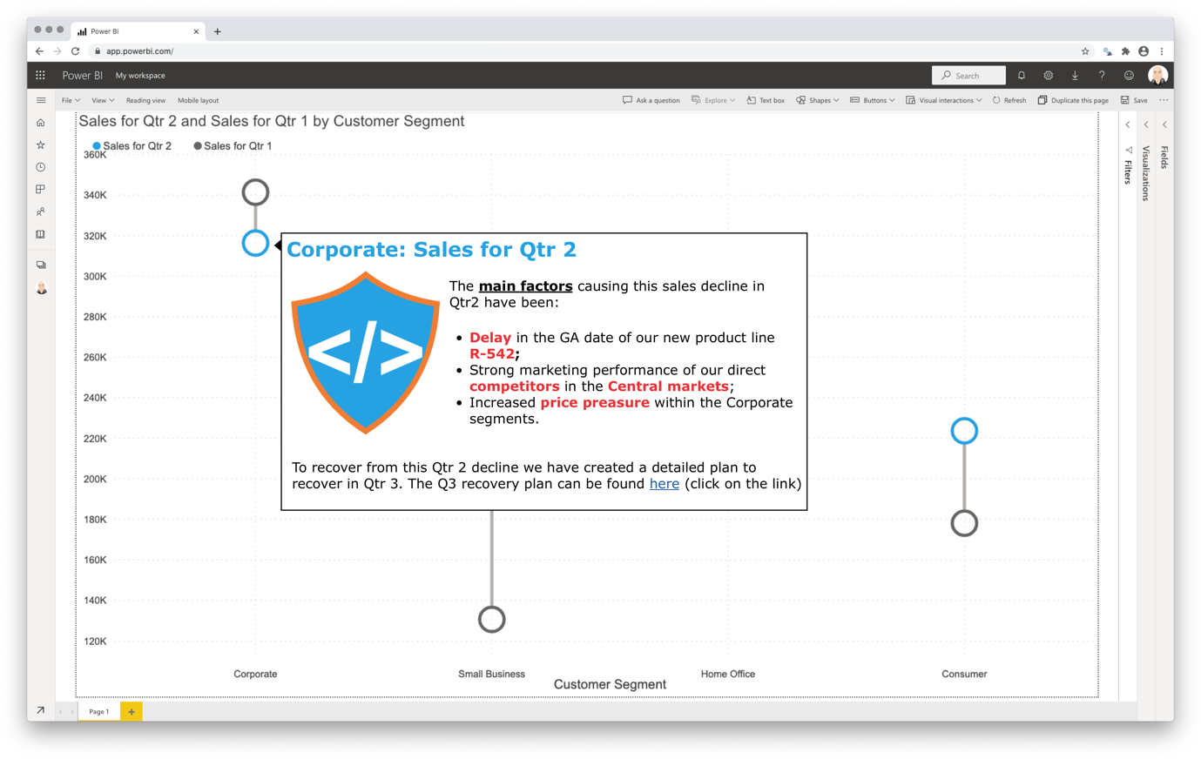
As of version 2.0 the Shielded HTML Viewer (in the image above used in the tooltip of a dumbbell chart) supports inline SVG and Data URL images. This way you can include any inline images in your Power BI reports and dashboards. Version 2.0 also includes support for the NAV-tag: now you can include HTML navigation menus to your reports. More information on the NAV-tag.

Furthermore, all functionality is available through the standard Power BI interface, so no need to learn a new interface.
Don’t hesitate and try the Shielded HTML Viewer now on your own data by downloading it from the AppSource. All features are available for free to evaluate the Shielded HTML Viewer within Power BI Desktop.
Please visit us at if you have any questions/remarks: https://visuals.novasilva.com.

graphomate charts 2021.4
The graphomate charts are designed to support you in creating meaningful reports and dashboards. They are compliant to the International Business Communication Standards (IBCS).
Thanks to numerous settings you can customize your charts down to the smallest detail.
Here is a small selection:
  - Freely definable variance graphs, without a limit on the number of graphs
  - Detailed number formatting, which automatically adapts the language of your operating system.
  - Show small multiples of a chart through drill down to another dimension
  - Create your own data scenarios – e.g. a certain format for actual or planned data - and assign them to each datapoint
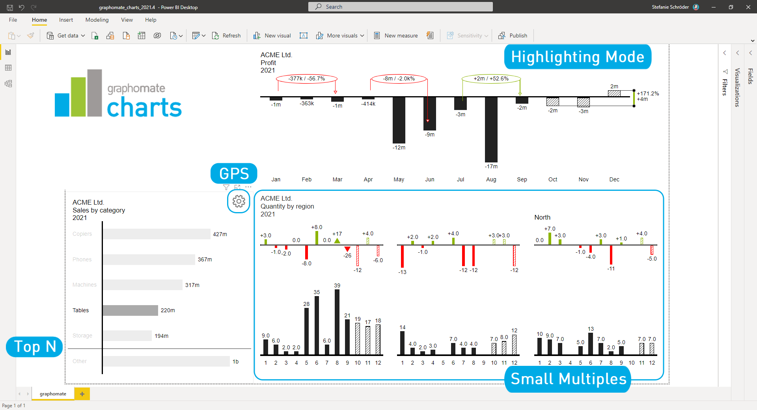
With the 2021.4 release we have improved the performance of the visual and added new features.
Quick access to the graphomate property sheet (GPS) via the gear wheel. Use the integrated search to quickly find and change properties.
Highlights - Highlight your findings with single Highlight and Multi-Highlights.
Display measures without dimensions in the categories.
Better sorting and setting options on the Format Pane of Power BI for the graphomate extensions
Go ahead and explore the graphomate charts by downloading it from the AppSource. Find the detailed documentation here.
Please read the documentation for more information.

Zebra BI Cards by ZADNJA VERZIJA
Meet the brand-new Zebra BI visual: Cards.
With this new visual you can now present your KPIs or your scorecard in a completely new way. Advanced features like focus mode, drill-through, dynamic comments, grouping and more, empower you to tell the whole story behind the values. Even more, your reports can now be blazingly fast as you can easily insert multiple cards in one visual!
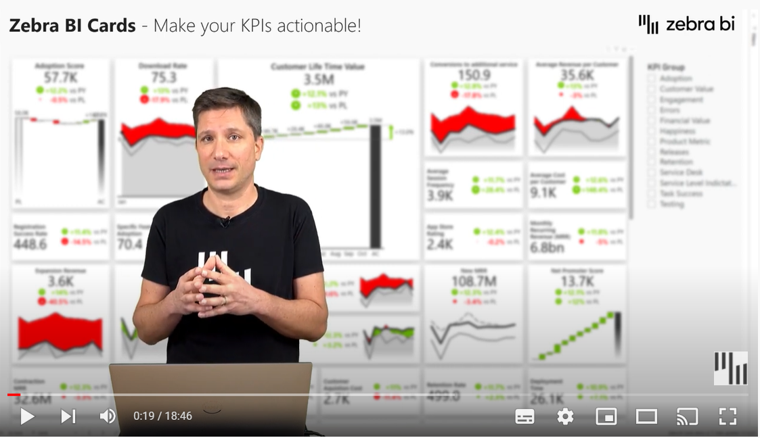
Key functionalities:
- See immediately what’s happening:
  - Show up to 3 comparisons
  - Time series for trends
  - Scaling of variance icons
- Dive deeper into data:
  - Dynamic comments
  - Drill through
  - Focus mode
  - Scaling option for charts on separate cards
  - Invert individual cards for negative KPIs
- Adjust the design:
  - Resize each card based on the KPI’s importance
  - Drag and drop to reorder cards
  - Chart slider on each card
  - Number formatting option for each card
  - Axis break for all charts
  - Custom colors
  - Card and row layout
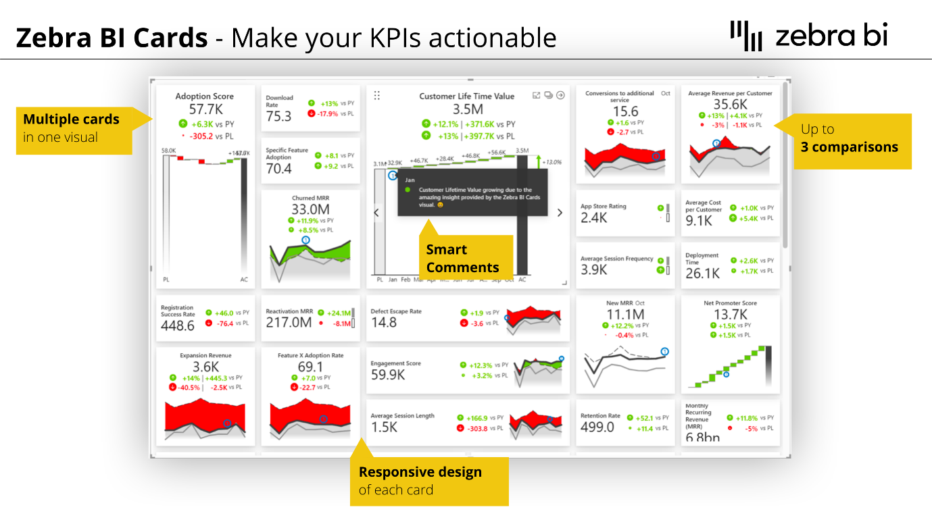
With Zebra BI Cards visual, we completed the toolkit for Actionable Reporting. Combine all its functionalities with Charts and Tables visuals and start presenting your data in an understandable and actionable way. For more information about how Zebra BI can take your reports to the next level, visit our website.

Try to use process mining through Business Intelligence by PmBI
In today’s digitalized world, we live with many process data and this data is a precious asset for having a better life and business. Process mining is the field that supports us in analyzing the business process data or any dataset with a sequential concept for discovering the overflows, bottlenecks, delays, different unique behavioral patterns and fraudulent activities and so on.
Don’t be afraid of applying process mining since it is not a hard and complex task anymore with PmBI. It provides a simple, quick and user-friendly tool for creating Power BI reports and dashboards to reveal many hidden valuable insights obtained from your real business processes and integrated data.
If your business suffers from the following challenges, then PmBI is beneficial for you:
- The targeted business value through the ongoing business processes is not achieved.
- Tired of complaining too much about overflows, delays, unknown increased costs, and fraudulent activities?
- You have spent a lot of money and time on deploying and customizing your business process applications.
Please visit us if you have any questions, contact, or remarks at: https://processm.com/
Watch the simple PmBI demo: https://www.youtube.com/watch?v=Pf75mNsnt-c

Drill Down Combo Bar PRO by ZoomCharts
Drill Down Combo Bar PRO lets you combine multiple chart types and apply rich customization options for all aspects of the report. Interactive drill downs and on-chart interactions make data exploration quick, easy, and fun.

Drill Down Combo Bar PRO, like all custom visuals by ZoomCharts, are mobile friendly and support: interactions, selections, custom and native tooltips, filtering, fetching more data, bookmarks, and context menu.
Main features include:
- Cross-chart filtering – select data points on multiple charts instead of using slicers
- On-chart interactions – click, pan, zoom-in/out to explore multiple drill-down levels
- Stacking and clustering – choose from various stacking options
- Static and dynamic thresholds – set thresholds to demonstrate targets or benchmarks
- Full customization – customize X and Y axes, legends, stacks, tooltip, fill settings, outlines
Most popular use cases:
- Sales & Marketing
- Human Resources
- Accounting and Finance
- Manufacturing

To evaluate Drill Down Combo Bar PRO on your own, get it now from the AppSource!
Learn More about our Drill Down Combo Bar Pro

Other

Visualize your data quickly from Power Apps and Dynamics 365 apps (preview)
We recently announced a new way to visualize your model-driven Power Apps and Dynamics 365 data stored within Dataverse. With a single click, Power BI automatically generates a set of visuals for you to explore and find insights within your data. This integration is great way to take advantage of the full power of the Power Platform. It’s also the latest extension of the quick creation experience that we’ve already shipped within the Power BI service and in SharePoint and Microsoft lists. You can read the full announcement in the dedicated blog post (it will be published in December 2021).
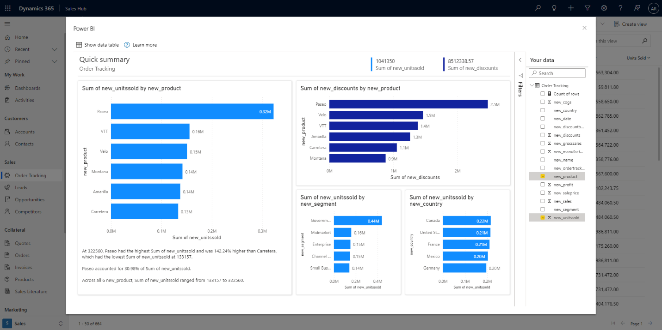

We’re currently previewing this feature within Power Apps, so for the option to show, an admin will need to enable it through the Power Apps Maker portal. You can read this article to learn more about configuring app properties within the Power Apps Maker portal.

